**ONTARIO EV LANDSCAPE**

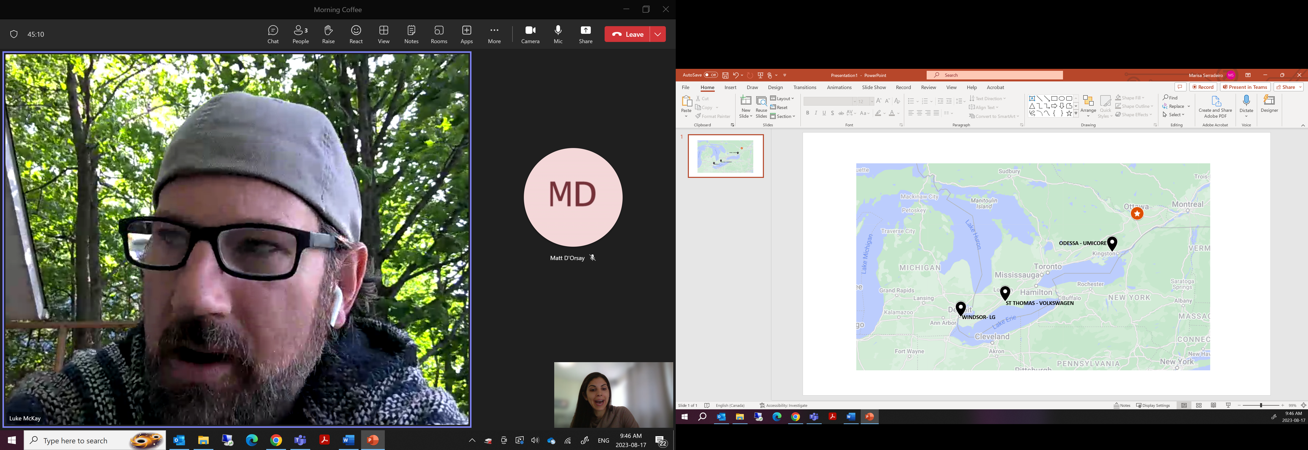

**Windsor Ontario - LG Energy Solution & Stellantis**

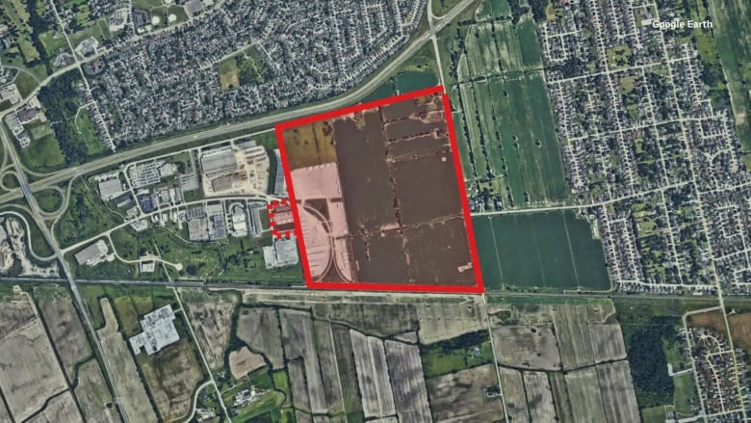

***9865 Twin Oaks Dr, Windsor Ontario***

* Joint venture between LG Energy Solutions and Stellantis - operational by 2025
* This was a land assembly acquisition by the City, estimated value around 45 million dollars (approx. $220,000 per acre), to be leased to LG/Stellantis
* The site is approximately 220 acres, and total building size estimated to be 4.5 million sf
* Victor Fedeli, minister of economic development, job creation and trade, told CBC News the province would provide up to $5 billion in tax breaks based on production over a 10-year term. Another $10-billion in tax breaks would come from the federal government

**Odessa Ontario - Umicore N.V.**

  
***5218 Taylor Kidd Blvd, Loyalist ON***

* Purchased from The Corporation of Loyalist Township
* Total of 355 acres purchased for $4,465,625 (Approximately $12,579.23/Acre)
* Construction to be completed by the end of 2025
* First plant to combine production of precursor cathode active materials and cathode active materials at the same facility.
* Facility will cost $1.5 Billion and create approximately 600 jobs

**St. Thomas, Ontario – Volkswagen**

**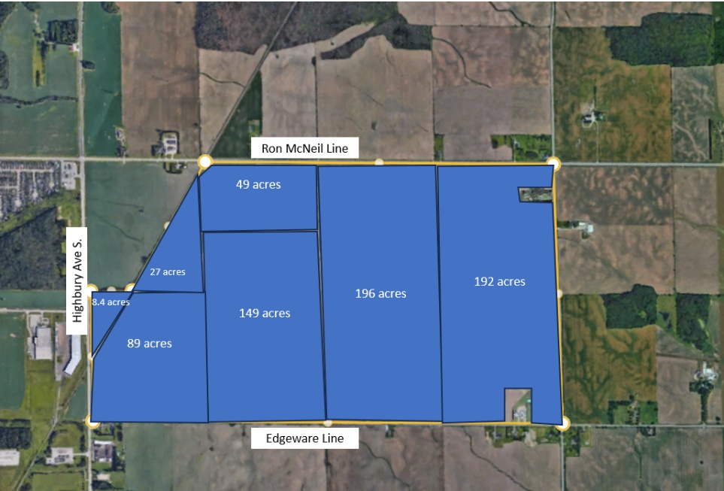  
*South of Ron McNeil Line, east of Highbury Avenue South.***

* Volkswagen is developing a new $7 billion dollar electric vehicle battery plant
* Expected completion in 2027
* The government of Ontario is providing $500 million in direct incentives to Volkswagen, as well as hundreds of millions to strengthen and grow St. Thomas, including highway expansions to allow for direct access to Highway 401
* Approximate 800 acre land assembly purchased by the City of St. Thomas in September 2022.

**Other EV Projects in Ontario**

**Oakville, Ontario – Ford**

* Ford is investing C$1.8 billion to transform Oakville (Ont.) Assembly Complex into a Canadian hub of electric vehicle manufacturing that will include vehicle and battery pack assembly; site transformation to reach a global run rate of 2 million EVs annually by the end of 2026
* Ford already owned their 487 acre site & is building a new 407,000 sf battery plant
* Provincial and Federal government total spend on this project is approx. $590 million

**Ingersol, Ontario - General Motors**

* GM converted their existing CAMI facility to Canada’s first fully scale EV manufacturing plant, costing approximately 2 billion dollars
* They will be building a new 400,000 sf facility on site
* Provincial and Federal governments contributed 4259 million each for the facility upgrades
* The site is already owned by GM – not land acquisition

**Brampton and Newmarket - Magna International**

* Expanding its operations across six locations in Ontario with a $471 million investment
* Subject to reaching a definitive agreement, the Invest Ontario Fund will provide $23.6 million for the six projects. Magna’s increased capacity will accelerate the industry’s shift to electric vehicles
* Magna Brampton: $265 million project to build a new 490,000 square-foot facility, producing electric battery enclosures
* Magna Newmarket: $24 million project to produce electronic latching units (front, hood and side-door latches) for Magna’s new electric vehicle platforms